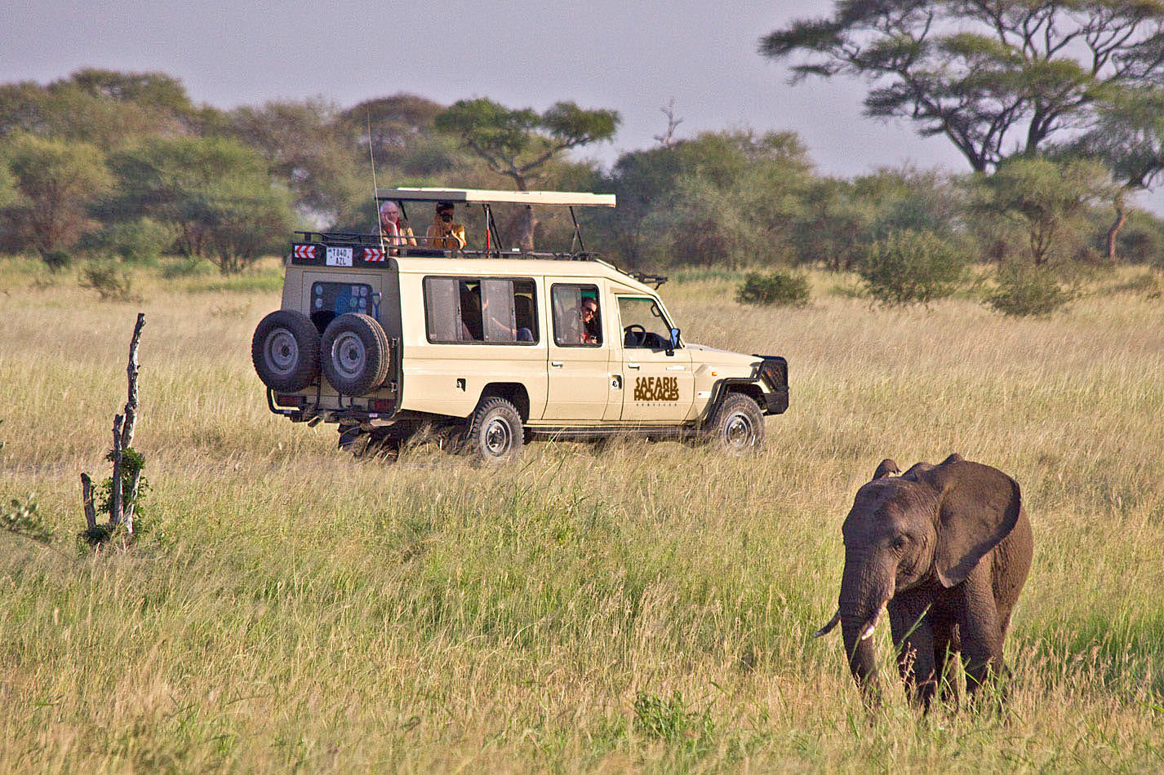
A time to explore and discover, Africa safari
2014
SAFARI BOOKING TERMS AND CONDITIONS

Tanzania Safaris Packages Services
P.O.Box 15460 Arusha,
Tanzania,
East Africa
Phone: +255713004481
Fax: 0736618027

BOOKING TERMS AND CONDITIONS

Changing in Prices
Rates quoted are correct at the time given and are subject to change without notice. Safaris Packages Services reserves the right to charge surcharges due to unavoidable circumstances beyond our control such as inflation, revised taxation or other fees. Such surcharges will be notified in writing and must be paid within 14 days of notification, making due allowance for normal transmission of funds. Non-payment may be construed as an act of cancellation and subject to the conditions of cancellation.

Deposit & Payment
Upon an agreed itinerary and price, you will be required to pay a deposit of 40% of your total safari quotation in order for us to reserve your holiday. On receiving your deposit and subsequent to a written (email) confirmation from Safaris Packages Services, your booking is considered "provisionally confirmed" and subject to the cancellation conditions given below. Payments will be in U.S. dollars, by bank draft wire or electronic transfer.

Payment Methods
We accept online transactions like Visa, MasterCard, America Express, JCB, and other money transfer such as Western Union, MoneyGram and Bank Wire Transfer. Please let us know your convenience payment method so we can give you details to use for process payments.

Cancellation after Booking
All cancellations must be made in writing (email is faster!). Telephone cancellations will not be considered valid. The date of the cancellation will be the date shown the email was sent, but for posted cancellations, the date of cancellation will be the date the letter is received, not the date it may be postmarked.

Cancellation Charges
Any cancellation of confirmed booking is subjected to the following charges;-
- Up to nine weeks before departure: 30% Deposit
- Eight weeks before departure: 50% of the safari cost
- Six weeks before departure: 65% of the safari cost
- Four weeks and below before departure: 100% of the safari cost.

Final Payment
Your final payment is due eight weeks before the safari commences and thereafter the total amount is forfeited in case of cancellation or no show

Cancellation Conditions
Upon an agreed itinerary and price, you will be required to pay a deposit of 40% of your total safari quotation in order for us to reserve your holiday. On receiving your deposit and subsequent to a written (email) confirmation from Safaris Packages Services, your booking is considered "provisionally confirmed" and subject to the cancellation conditions given below. Payments will be in U.S. dollars, by bank draft wire or electronic transfer.

Cancellations Conditions:
- No cancellations or notifications of reduced numbers booked are accepted by phone. Only written notifications are considered valid. Written notifications include email (from original e-mail of the correspondent clients).
- No cancellations or notifications are considered valid unless reconfirmed cancelled in written form by Safaris Packages Services.
- No-shows are considered cancelled at the date of your first expected arrival.

No refunds shall be given for: lost travel time or necessary substitution of facilities, especially by virtue of force majeure;
- Itineraries necessarily amended after departure, especially by virtue of force majeure;
- For circumstances beyond The Company's control which necessitate alternative arrangements being made to ensure safety and/or further participation of enjoyment.
- If the participant does not appear for any accommodation, service or excursion without first notifying The Company in writing.
- If the participant leaves after the safari has commenced.
- You may also be responsible for any fees imposed by hotels, airlines etc., that are over and above your land arrangements, due to your cancellation of your original date bookings.
Cancellation by Safaris Packages Services:
Safaris Packages Services reserves the right to make changes, where unavoidable, to itineraries, holidays and services both before and after a booking is confirmed due to but not limiting: -
- Bad weather
- Late payments
- Availability of service
- Security
- Other unavoidable circumstances

Host Clients
Transportation
The Company reserves the right to employ the services of sub-contractors. No vehicle may be driven by a client participant at any time, unless it is hired vehicle as a self-drive. Carnage (by land, sea and air) is subject to the terms and conditions of the carrier and to International Conventions, some of which limit liability. Land, sea and air travel are also subject to operational decisions of carriers and ports, which may result in cancellation, delays or diversions over which Safaris Packages Services has no control and for which The Company can accept no liability whatsoever.

Accommodation
Safaris Packages Services reserves the right to substitute accommodations with similar accommodation of the same category and standard.
Liability of the Company:
- Safaris Packages Services acts as a booking agent in all matters relating to hotel and lodge accommodation, tours, airlines/charters, bus companies, ground transportation, boat owners and other independent contracts providing accommodation, transportation and/or other services, each of which is an independent company outside Safaris Packages Services control and each of which has its own terms and conditions. As such, Safaris Packages Services shall not be liable for injury, delays, loss or damage of any kind arising from other independent contacts.

- Safaris Packages Services liability to participants carried in our own vehicles is governed by the laws of Tanzania and no other country.

- The Company reserves the right to employ subcontracts for all or part of its services; in the event of such right the terms of this clause applies.

- Whilst every care is taken, The Company cannot be held responsible for loss or damage to luggage.

Travel Documentation
You are responsibility for ALL your travel documents and vaccinations, which must be current and correct. Safaris Packages Services shall not be responsible for any delay, interruption, or cancellation resulting from participant failure in this regard.

You may contact us via

Email: trave@safarispackages.com or safarispackages@gmail.com
Mob: +255713 004 481
Website: www.safarispackages.com

Thank you for choosing
Tanzania SafariS Packages



